Engineering Stem Cells as an Effective Cancer Treatment
February 2, 2015
Review of “Engineering toxin-resistant therapeutic stem cells to treat brain tumors” from Stem Cells by Stuart P. Atkinson
Pseudomonas exotoxin (PE) can enter and kill cells by blocking protein synthesis [1] and linking this toxin to antibodies which target proteins (IL13 and EGFR) specifically overexpressed in glioblastomas (GBM) may represent a potentially efficient anti-tumor therapy. However, previous clinical trials of IL13-PE in GBM did not deliver the sought after survival benefit [2, 3], likely due to the short half‐life of IL13‐PE and coupled with ineffective delivery [2]. Now researchers from the group of Khalid Shah (Harvard Stem Cell Institute) have developed a new therapeutic strategy for the treatment of GBM; the development of toxin‐resistant human neural stem cells (hNSCs) which secrete PE-cytotoxins (IL13‐PE or EGFR targeted nanobody (ENb)‐PE). Using a mouse model, they show that administration of these cells after surgical removal of tumors prolongs toxin delivery time, eliminates the need for multiple invasive treatments, and significantly reduced mass [4].
The first step in this strategy involved making the NSCs PE-resistant by mutating elongation factor‐2 (EF‐2), utilizing single stranded oligonucleotides, into a toxin‐resistant variant, followed by transfection with plasmids encoding PE‐cytotoxins to create a stable toxin expressing cell line (See figure). PE targets EF-2 for inactivation which inhibits protein synthesis leading to cell death. These modifications had no effect on cell proliferation and did not overtly alter protein secretion, but co-culture experiments of engineered NSCs and GBM cell lines found a reduction in GBM viability relative to the level of the cognate receptor expression (ILIL13Rα2 and EGFR) through inhibition of protein synthesis and promotion of cell cycle arrest.
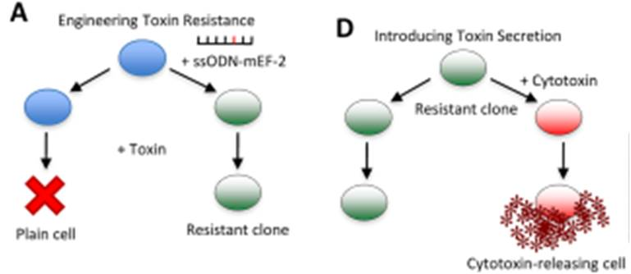
Application of the cells in a mouse tumor resection model via synthetic extracellular matrix (sECM) encapsulation demonstrated an increased anti-tumor activity. Tumor masses were evident in control mice and IL13‐PE infusion mice, but application of the doubly engineered NSCs led to the complete absence of tumor mass, which conferred a statistically significant survival benefit. Finally, the authors demonstrated that engineered IL13‐PE-NSCs had therapeutic efficacy against primary patient‐derived GBMs that express IL13Rα2, but did not affect any normal stem cell lines.
This is the first report of an effective cell-engineered anti-tumor therapy with a high efficacy in mouse models and against patient-derived cancer cells through the prolongation of delivery time and elimination of multiple invasive administrations. Hopefully this strategy will propel human trials to succeed where the previous IL13‐PE trial failed [2], and lead to other “tailored” anti-tumor therapies. Some barriers still do lie in the way; such as questions over limiting NSC cell numbers and a larger surgical site, and the potential for immunogenic reactions.
Discussion Points
- Can this be applied to other stem cell lineages?
- Can other specific target be used against other tumor types with a characteristic protein overexpression?
- Can targeting multiple proteins increase anti-tumor efficacy?
- Will this therapy be effective in human trials?
- Can induced pluripotent stem cells provide the solution to cell number and immunogenicity problems?
References
- Hwang J, Fitzgerald DJ, Adhya S, et al. Functional domains of Pseudomonas exotoxin identified by deletion analysis of the gene expressed in E. coli. Cell 1987;48:129-136.
- Kunwar S, Chang S, Westphal M, et al. Phase III randomized trial of CED of IL13-PE38QQR vs Gliadel wafers for recurrent glioblastoma. Neuro Oncol 2010;12:871-881.
- Wang Y and Jiang T Understanding high grade glioma: molecular mechanism, therapy and comprehensive management. Cancer Lett 2013;331:139-146.
- Stuckey DW, Hingtgen SD, Karakas N, et al. Engineering toxin-resistant therapeutic stem cells to treat brain tumors. Stem Cells 2015;33:589-600.

